Current Controller IP Test Spec
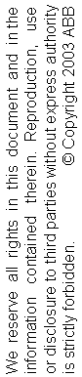

Edition | Date | Issued by | Comments
0.1 | 09-11-25 | CNABB / Ye-Ye Zhang | Proposal

TABLE OF CONTENTS

1. general 3
1.1 References 3
1.2 Definitions 3
1.3 Test object 4
2. Unit Level testS 5
2.1 Check FSL Communication 5
2.2 Check State Machine 6
2.3 Upload Firmware Info 7
2.4 Download Configuration Data 8
2.5 Verify Process Data and Feedback Data 9
2.6 Verify ADC Output 10
2.7 Verify Reset Functionality 10
3. Board level testS 11
3.1 Test Clock and Interrupt 11
3.2 Test FSL Communication 11
3.3 Test State Machine 11
3.4 Test Configuration 12
3.5 Test Process Data and Feedback Data 12
3.6 Test ADC Output 12
3.7 Test PWM Output 12
3.8 Test Cyclical Input / Output 13
3.9 Test Reset Functionality 13
4. MOTor Level testS 14
5. VTS Revision history 15
5.1 Edition 0.1 15

general
This document contains the verification test specification (VTS) for the Current Controller IP core.

The below tests are necessary to verify the function of the IP core.

References
[1] Firmware C19 Specification
[2] Current Controller IP Transplant Specification

Definitions
The following definitions are stated for this document:

Unit level
The firmware IP core is tested as a single unit in test bench simulation.

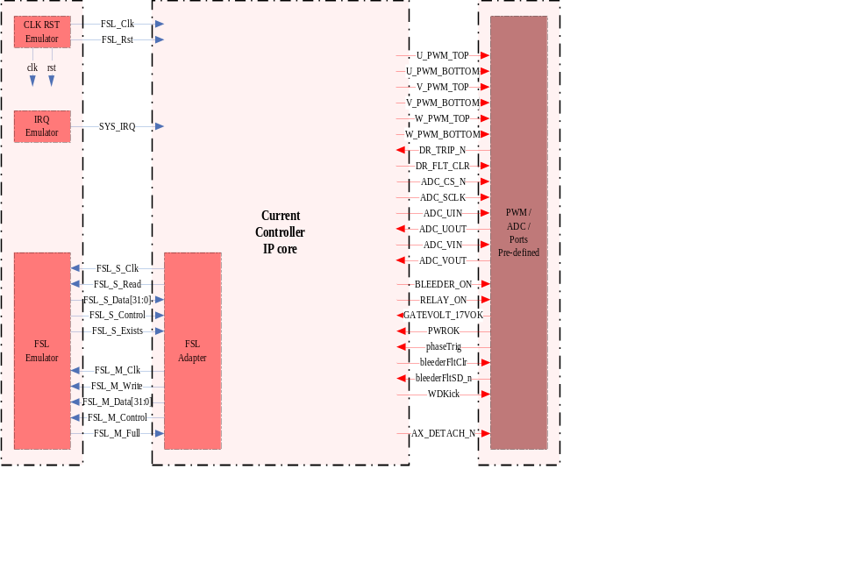

Board level
Testing is done in a control board system without other peripherals.

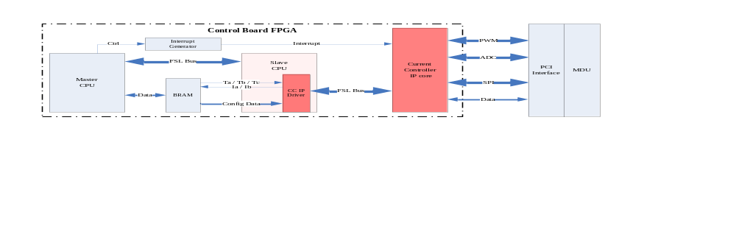

Motor level
The test is done on a complete motor-running system.

Test object
The following material was used in this test:

Unit Level testS
Unit level
Testbench Software | Xilinx ISE 10.1i
Simulation Software | ModelSim XE 6.3c
Board level
Testbench Software | Xilinx EDK 10.1i
FPGA | Xilinx Virtex 5
Testing Platform | Control Board / MDU
Power Supplier | DC 24V
Oscilloscope | Tektronix TDS 754C
Motor level
Testbench Software | Xilinx EDK 10.1i
FPGA | Xilinx Virtex 5
Testing Platform | Control Board / MDU / Servo / EIB
Power Supplier | DC 24V
Oscilloscope | Tektronix TDS 754C
Motor | Yasakawa Motor with Encoder
The firmware IP core is tested as a single unit in test bench simulation.

The simulation should be done in ModelSim environment. Parameters list as follow.

Ports | Settings
FSL_Clk | Set clock frequency at 100MHz
FSL_Rst | Set reset active for 200ns and then set passive
SYS_IRQ | Interrupt IRQ repeats every 63us
FSL (BUS) | Blocked, 32bit width, no depth as buffer FIFO but operating in real-time
PWM (BUS) | Keep OPEN
ADC (BUS) | Keep UOUT and VOUT low, others OPEN
DR_TRIP_N | Keep passive (high)
GATEVOLT_17VOK | Keep active (high)
PWROK | Keep active (high)
phaseTrig | Keep passive (low)
bleederFltSD_n | Keep passive (high)
SELECTEDFLASH | Keep active (high)
Default | Keep OPEN

Check FSL Communication
The IP core initialization period is less than 150ns. After well-initialization, the IP core will send out InitConnect words automatically. The format of these words is listed as follow. If these words are correct, the IP core initialization is finished and the FSL communication is correct.

Step | Action | Result
1 | Get 4 InitConnect words via FSL. | OK
2 | Check the value of these InitConnect words is expected or not. | OK

InitConnect | Addr | Value
FW_Revision | 0x1004 | 0x0035
PU_DSQC | 0x1006 | 0x0299
PU_Version | 0x1008 | 0x0001
PU_Revision | 0x100A | 0x0001

Check State Machine
The main state machine in this IP core implements the original ESM (EtherCAT State Machine) as follow. The state change is complied by 2 command words: the first tells the IP core to change state; the second defines which state to be changed into. After the IP core executes the state change command, it will send back 2 status words as feedback. (If the first one is 0x01340000, it indicates no error during state change.)

Step | Action | Result
1 | Change state from Init to PreOp.  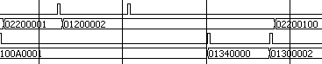 | OK
2 | Change state from PreOp to SafeOp  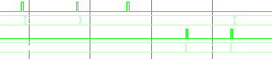 | OK
3 | Change state from SafeOp to Op  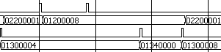 | OK
4 | Change state from Op to SafeOp  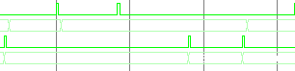 | OK
5 | Change state from SafeOp to PreOp  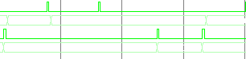 | OK
6 | Change state from Op to PreOp  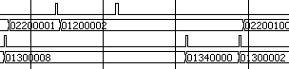 | OK
7 | Change state from PreOp to Init  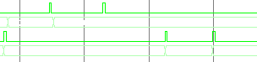 | OK
8 | Change state from SafeOp to Init  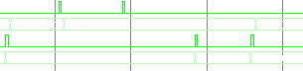 | OK
9 | Change state from Op to Init  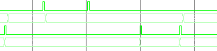 | OK
10 | Change state from Init to Init  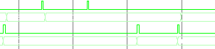 | OK
11 | Change state from PreOp to PreOp  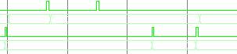 | OK
12 | Change state from SafeOp to SafeOp  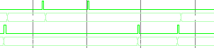 | OK
13 | Change state from Op to Op  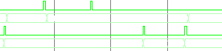 | OK
14 | Change state from PreOp to Op (should report error)  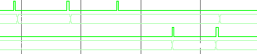 | OK
15 | Change state from Init to SafeOp (should report error)  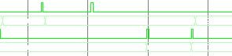 | OK
16 | Change state from Init to Op (should report error)  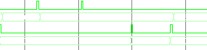 | OK

State | Description
Init | Startup
Bootstrap | Reset
PreOP | Configuration
SafeOP | Process data input to CPU
OP | Process data input and output

Upload Firmware Info
The FirmwareInfo words could be uploaded in PreOp state. The format of these words is listed as follow.

Step | Action | Result
1 | Send fw_info command to IP core.  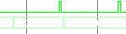 | OK
2 | Receive firmware info from IP core. | OK

FW_Info | Addr | Value
FW_Version | 0x1760 | 0x0000
FW_Revision | 0x1762 | 0x0035
Latest_Supported_RoboCat_Version | 0x1764 | 0x0000
Min_PWM_Delay_Time | 0x1766 | 0x04B0
Max_PWM_Delay_Time | 0x1768 | 0x1194
Process_Data_Output_Length | 0x176A | 0x0028
Process_Data_Input_Length | 0x176C | 0x0028

Download Configuration Data
The ConfigData words should be downloaded in PreOp state. Though the IP core does not sends feedback, it has some internal signals to indicate the configuration status as follow.

Step | Action | Result
1 | Send configuration command to IP core.  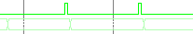 | OK
2 | Send configuration data to IP core. | OK

ConfigData | Description | bits | Addr | Value
MaxLostFrames | Maximum Number of Lost/ignored consecutive reference messages. | 4 | 0x1610 | 0x0003
MDUProtocolVersion | Process data protocol version for MDU | 8 | 0x1612 | 0x0000
ADC_BleederTurnOnLevel | Rectifier Config. A/D converter value for turn on level for the bleeder. | 12 | 0x1614 | 0x01AE
ADC_BleederTurnOffLevel | Rectifier Config. A/D converter value for turn off level for the bleeder. | 12 | 0x1616 | 0x01A4
ADC_BleederTestLevel | Rectifier Config. A/D converter value representing the DC level that the DC link shall drop to when engaging the bleeder during startup test | 12 | 0x1618 | 0x00F1
ADC_DCSettleLevel | Rectifier Config. A/D converter value representing that DC is stable when its ripple is less than this value | 12 | 0x161A | 0x0003
ADC_DCEngageLevel | Rectifier Config. A/D converter value for engage the relays, i.e. switching inrush circuit to running mode | 12 | 0x161C | 0x0109
ADC_DCDisengageLevel | Rectifier Config. A/D converter value for disengage the relays, i.e. switching inrush circuit to charging mode | 12 | 0x161E | 0x00D6
RectifierConfigValid | Mains AC Type:  0 – Not Configured  1 – Configured  2 – 15 Reserved | 4 | 0x1620 | 0x0001
OnePhaseMains | 0 – Three Phases  1 – One Phase | 1 | 0x1622 | 0x0001
DeadtimeInverter1 | Deadtime in 10 ns resolution | 12 | 0x1624 | 0x012C
DeadtimeInverter2 | Deadtime in 10 ns resolution | 12 | 0x1626 | 0x012C
DeadtimeInverter3 | Deadtime in 10 ns resolution | 12 | 0x1628 | 0x012C
DeadtimeInverter4 | Deadtime in 10 ns resolution | 12 | 0x162A | 0x012C
DeadtimeInverter5 | Deadtime in 10 ns resolution | 12 | 0x162C | 0x012C
DeadtimeInverter6 | Deadtime in 10 ns resolution | 12 | 0x162E | 0x012C
WatchdogTimeout | 10 ns resolution-value to use as timeout when no data is received by the Slave. The supervision should be enabled when the first package arrive after entering OP state. | 16 | 0x1630 | 0x03E8
WatchdogTimeoutInterval | 10 ns resolution-value to use as timeout for next package when a package is lost. | 16 | 0x1632 | 0x189C

Verify Process Data and Feedback Data
The ProcessData and FeedbackData should be run in either SafeOp or Op state. Their data format is listed as follow. All the addresses of process data and feedback data should be verified.

Step | Action | Result
1 | Send process command to IP core.  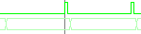 | OK
2 | Send process data to IP core. | OK
3 | Receive feedback data from IP core. | OK

Process data area for outputs

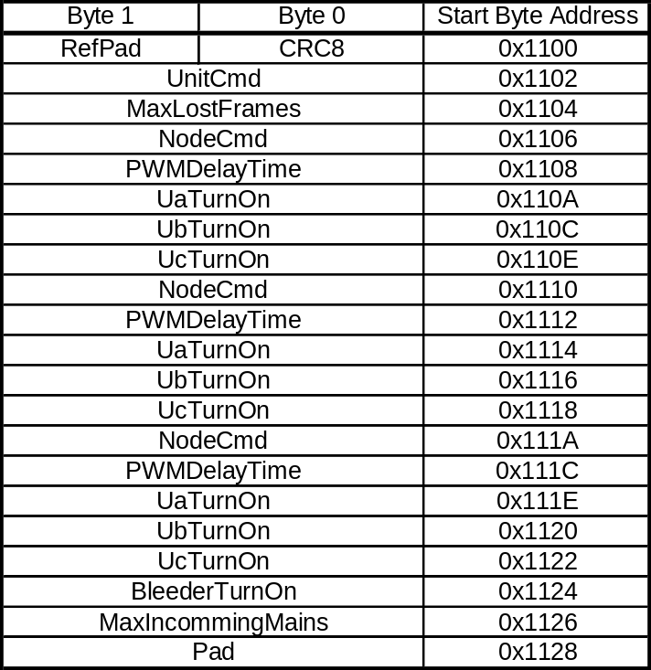

Process data area for inputs

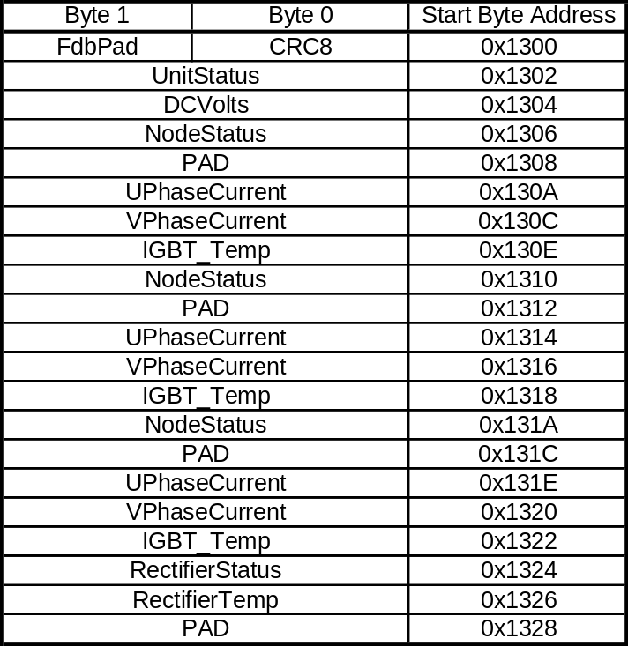

Verify ADC Output
After ProcessData and FeedbackData are verified ok, there should be ADC signals at output ports for six axes. Note that PWM signal is not available due to that the DR_TRIP input signals are not emulated, but to be set as constants.

Step | Action | Result
1 | Check the interval between two ADC clock active times, which should be 63us  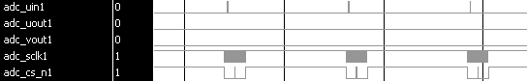 | OK
2 | Check the frequency of ADC clock, which should be 6.25MHz  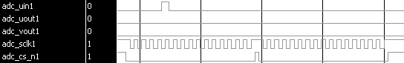 | OK
3 | Repeat step1 and step2 to check all six axes | OK

Verify Reset Functionality
Set the reset signal to be active in the emulator after a certain time. Then check all the test cases above again to verify the IP core reset functionality and stability.

Step | Action | Result
1 | After checking all test cases above, wait 1ms | OK
2 | Set reset signal to be active for 200ns, and then set it to be passive | OK
3 | Redo test case 2.1 to 2.5 again | OK

Board level testS
Testing is done in a control board system without other peripherals but MDU via PCI interface.

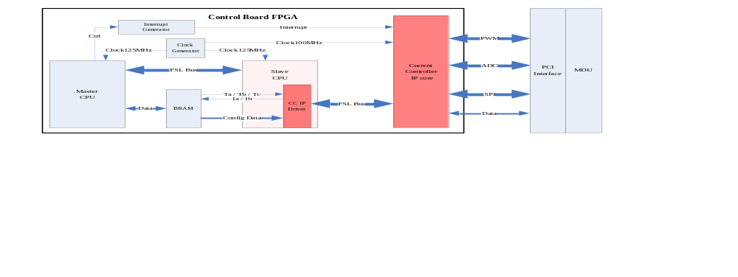

The test system is based on a Control Board FPGA. And a MDU is used for power supply and ADC / PWM test. Some important components inside FPGA list as follow.

Component | Description
Clock Generator | Set clock frequency at 125MHz for system, but 100MHz for the IP core
Interrupt Generator | Configurated by master CPU and generate interrupt every 63us
Master CPU | Control, send commands to slave and so forth
Slave CPU | Execute commands from master, do algorithms calculation and CC IP driver
CC IP core | Need to be tested
BRAM | Share memory for public data storage

The board level tests below not only focus on the Current Controller IP core, but also verify its driver in slave CPU.

Test Clock and Interrupt
The clock and interrupt signals should be connected out to the FPGA test pins. Then these signals could be tested by oscilloscope.

Step | Action | Result
1 | Connect sys_clk_s, duf_clk_s, intMaster to test pins | OK
2 | Test sys_clk_s frequency, which should be 125MHz | OK
3 | Test duf_clk_s frequency, which should be 100MHz | OK
4 | Test intMaster repeat cycle period, which should be 63us | OK

Test FSL Communication
With respect to the software driver part, the slave_duf_init function would judge whether IP core is initialized successfully or not. If the IP core initialization is finished and the FSL communication is correct, no error (ERROR_NONE) would be reported.

Step | Action | Result
1 | Load slave_duf_init function with xil_printf enabled | OK
2 | Function passed with ERROR_NONE status | OK

Test State Machine
The slave_duf_state function holds an argument to identify which state to be changed. All state change situations should be covered in this test case.

Step | Action | Result
1 | In Init state, load slave_duf_state(ESM_AL_PREOP) | OK
2 | In Init state, load slave_duf_state(ESM_AL_SAFEOP) | NOK
3 | In Init state, load slave_duf_state(ESM_AL_OP) | NOK
4 | In PreOp state, load slave_duf_state(ESM_AL_SAFEOP) | OK
5 | In PreOp state, load slave_duf_state(ESM_AL_OP) | NOK
6 | In SafeOp state, load slave_duf_state(ESM_AL_PREOP) | NOK
7 | In SafeOp state, load slave_duf_state(ESM_AL_OP) | OK
8 | In Op state, load slave_duf_state(ESM_AL_PREOP) | OK
9 | In Op state, load slave_duf_state(ESM_AL_SAFEOP) | OK
10 | Reset to Init state related… (TBD) | NOK
11 | Boot state related … (TBD) | NOK

Test Configuration
In PreOp state, load slave_duf_config function to download the ConfigData. If the IP core configuration is correct, no error (ERROR_NONE) would be reported.

Step | Action | Result
1 | Change state machine to PreOp state | OK
2 | Load slave_duf_config function with xil_printf enabled | OK
3 | Function passed with ERROR_NONE status | OK

Test Process Data and Feedback Data
In either SafeOp state or Op state, load slave_duf_safeop_put, slave_duf_safeop_get, slave_duf_op_put, and slave_duf_op_get respectively. Typically, there should be no error (ERROR_NONE) status.

Step | Action | Result
1 | Change state machine to SafeOp state | OK
2 | Load slave_duf_safeop_put function with xil_printf enabled | OK
3 | Function passed with ERROR_NONE status | OK
4 | Load slave_duf_safeop_get function with xil_printf enabled | OK
5 | Function passed with ERROR_NONE status | OK
6 | Change state machine to Op state | OK
7 | Load slave_duf_op_put function with xil_printf enabled | OK
8 | Function passed with ERROR_NONE status | OK
9 | Load slave_duf_op_get function with xil_printf enabled | OK
10 | Function passed with ERROR_NONE status | OK

Test ADC Output
After ProcessData and FeedbackData are tested ok, there should be ADC signals at MDU (or Inverter Board) for six axes. Test all kinds of ADC signals one by one for each axis.

Step | Action | Result
1 | Check the interval between two ADC clock active times, which should be 63us | OK
2 | Check the frequency of ADC clock, which should be 6.25MHz | OK
3 | Check the interval between two ADC UIN active, which should be 63us | NOK
4 | Check the interval between two ADC chip select waveform, which should be 63us | NOK
5 | Test ADC clock and ADC UOUT simultaneously to read out the feedback data | NOK
6 | Test ADC clock and ADC VOUT simultaneously to read out the feedback data | NOK
7 | Repeat step1 and step2 to check all six axes. | OK

Test PWM Output
If PWM_ON is enabled in ConfigData, PWM output waveform should be active when ADC signals are active. Note that PWM signals are comprised of two 3-axis group. In another word, though ADC signals could be active in six axes, PWM commands could be sent only in three axes a time. Therefore, axes 1 / 2 / 3 would receive PWM commands only in odd times; axes 4 / 5 / 6 would receive PWM commands only in even times.

Step | Action | Result
1 | Set the UnitCmd with axes 1 / 2 / 3 in odd times and axes 4 / 5 / 6 in even times | OK
2 | Check the frequency of PWM U_TOP, which should be 8KHz (synchronous) | OK
3 | Check the frequency of PWM U_BOTTOM, which should be 8KHz (synchronous) | OK
4 | Check the frequency of PWM V_TOP, which should be 8KHz (synchronous) | OK
5 | Check the frequency of PWM V_BOTTOM, which should be 8KHz (synchronous) | OK
6 | Check the frequency of PWM W_TOP, which should be 8KHz (synchronous) | OK
7 | Check the frequency of PWM W_BOTTOM, which should be 8KHz (synchronous) | OK
8 | Change Duty Cycle parameters, and check the Duty Cycle in steps from 2 to 7 | OK
3 | Repeat steps from 2 to 8 to check all six axes | OK

Test Cyclical Input / Output
In the software interface, the IP driver gets parameters Ta Tb Tc for process data from shared bram. The IP driver then converts and sends it to IP core. About 31us later, the IP driver could receive feedback data. It would be converted to Ia Ib and be put into shared bram.

Step | Action | Result
1 | Change state machine to SafeOp state | OK
2 | Set values of Ta Tb Tc in shared bram | OK
3 | Load slave_duf_safeop_put function with ERROR_NONE status | OK
4 | Load slave_duf_safeop_get function with ERROR_NONE status | OK
5 | Check values of Ia Ib in shared bram | OK
6 | Change values of Ta Tb Tc and redo steps from 3 to 5 | OK
7 | Change state machine to Op state | OK
8 | Redo steps from 2 to 6 in Op state | OK
9 | Repeat steps above to check all six axes | OK

Test Reset Functionality
Set the reset in board level after a certain time. Then check all the test cases above again to verify the IP core reset functionality and stability.

Step | Action | Result
1 | After checking all test cases above, wait 1ms | OK
2 | Reset the board | OK
3 | Redo test case 3.1 to 3.8 again | NOK

MOTor Level testS
TBD…

VTS Revision history

Edition 0.1

